Organizing a Student Entrepreneurship Market

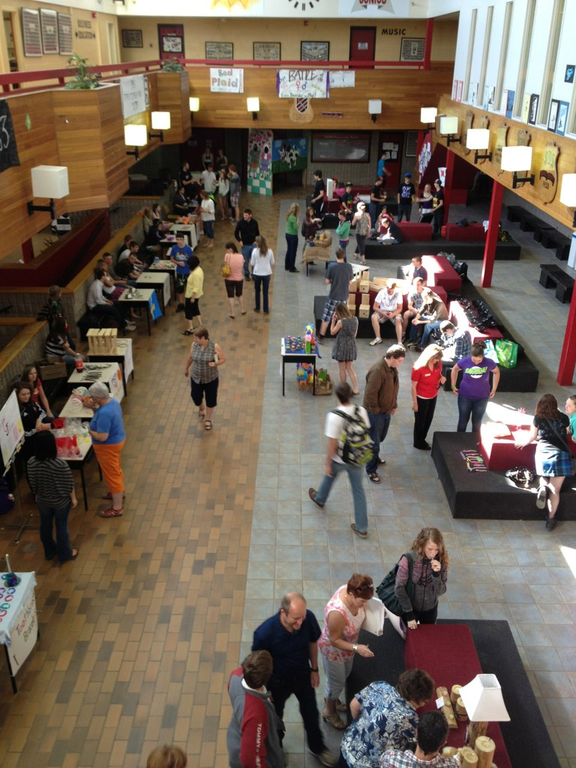

Anna Sarah-Jane Smith November 2012

**Introduction**

In the province of New Brunswick, Entrepreneurship is offered as an elective to students at the high school level. The curriculum offers teachers and students the perfect opportunity to engage in meaningful Project Based Learning (PBL). The purpose of this document is to help guide teachers through the process of planning and organizing, an entrepreneurship market with their students. This document explores the planning side for the day of a market **not** the business plan portion of the project. Nor is it a planning guide for students and their projects.

**What is a Student Market?**

A student entrepreneurship market is a farmers market style event where students are the vendors. Students must create a product or service that they have an interest in. The product or service can already exist but they must innovate it and adapt it for their target market(s). They must prepare a business plan around their idea that outlines; market research, financial analysis, sales projections and other business related items. On market day, students set up their booth and sell their product or service for a two to three house period.

**Why a Market?**

“There is no reason to be hesitant… becoming an entrepreneur is a learning experience.” – Savannah Britt

A market provides students with the chance to learn by doing, problem solving and growing as individuals. It gives students the opportunity to take theory and apply it to an everyday situation. Through the market, students engage in an authentic learning experience that allows them to showcase their talents and abilities to fellow students, teachers, friends and family. Through the market students can develop self-confidence because they were able to complete a large scale project that they never thought possible.

**Finding a Space**

It is important to find a location/space that can accommodate the requirements for the market. The space should be large enough for the students to set up their booths and still allow for ease of movement for customers. This will require more space than assumed; as desks/tables and products always take more space than originally thought. It is also important for customers to have enough space to move around freely between tables and look at the products without feeling crowded. If vendors have electricity requirements it will be important to have a space that is equipped with electrical outlets.

Some possible location suggestions at a school could be; the gymnasium, lobby, cafeteria, or library. All of these locations can provide enough space depending on the number of vendors and electrical requirements needed.

**Advertising**

Advertising for the market is very important. This allows parents, community and the school to become aware of the event; attend and support the market. It is important to access any free forms of advertising you can. Below outlines the different forms of “Free Media” that can be used and suggestions for getting started:

**Local Radio Stations:**

Most radio stations will offer free on-air notices for non-profit and school events. This involves either calling in and recording your message for the radio or emailing. For either point of contact it will be important to write a clear and concise message. Some radio stations even have a community events calendar that you can submit your event to.

Create a list of radio stations in your area that offer community events announcements. Make sure the list contains contact information for the station and what they require to be listed in the community events. This list can be used the next time you have a market.

**Local News Papers:**

There are local newspapers that will run free community events listings for non-profit and school groups. It is important to keep your event listing clear and concise as there is usually a limit of twenty-five to forty words.

Create a list of the local papers that offer free community event postings. Make sure your list includes contact information and listing requirements. This list can be used the next time you have a market.

**School Talk-Mail Messages:**

Most schools have a talk-mail message service. This service can be used to send a talk-mail message home to the school population informing them of school events and announcements. Check with your school administration to determine if this is possible and how to get your message sent home via talk-mail. It will be important to keep your message brief as if could be one of several in a message home.

**Contact Parents:**

Taking the time to contact parents of the students who are participating in the market is a great way to have them attend. If parents are made aware of the large event their child is taking part in most will take the time to attend and support them. This contact home can also help in being proactive to solving any possible issues with the project.

**Social Media:**

Some social networking sites have the ability to create an online event. Creating an event online allows students to upload pictures of their products and invite people from their community who might not be aware of the event. In using this option it will be important to teach the students how to market their product in a virtual environment, answer questions and when not to respond. Social media can be a great way to spread word of the event but it is not without drawbacks. If you are not comfortable using social media and any issues that may arise, it is best left alone.

**Posters:**

Posters are a great way to help advertise the market. Hanging posters up in the entrance of the school and around the school can allow visitors and school people to learn about the event. Posters can be given to students to find a location around their community. There are many community locations where posters can be put up: local stores, community centers, churches and other relevant locations.

Ensure the poster lists the: location, date, time and a few examples of products available. The poster should be photocopier friendly to keep cost at a minimum.

*This poster is an example of one used at a previous market at Sussex Regional High School. The poster is easy to read, catches the eye and is photocopier friendly.*



**Sponsors**

There are many community groups that could be willing to help out the project. This help could range from classroom guest speakers, to mentoring student(s) through their projects. Local enterprise groups, banks, community development agencies, credit counselling groups, New Brunswick Securities Commission and local entrepreneurs would all be great options available to you. It is up to you to determine how and if these groups fit into your plans for the market and with your students.

**Vendor Placement**

Determining vendor placement can feel like a daunting task as there are many things to consider. It is helpful to draw out a floor map of the market location with desk/table placements. On your floor map, place those who need electricity first to ensure their needs are meet. Place those students who have large space requirements second. Things that need a larger space are photo-booths, carnival style games and etc. Place those students who will have personality conflicts with other students third. Finally fill in the other vendors, ensuring that similar products are not beside each other.

Once you have placement determined allow room for adjustment(s) when setting up for the market. Flexibility in placement is important when setting up. This flexibility will allow you room to solve problems that may arise on the day of the market.

**Student Involvement**

“I think what teenagers lack is the belief that they can be unique and extraordinary in life.

Make the most of your age because you’re not going to be a teenager forever!” – Sabirul Islam

The chart below outlines what activities and jobs students can do to help organize the market. Giving students jobs to do for the market outside of their booth will allow them to appreciate the amount of work that is necessary for this type of event. It also allows them to take on a larger role of responsibility that some students want and need. There are a few blank rows provided to you for notes or other involvement items.

|  |  |
| --- | --- |
| **What Students Can Do** | **Action Items** |
| **Find businesses and places around the community willing to hang up a poster for the market** | * Give posters to student(s) * Provide guidelines for places to display poster |
| **Create a poster to promote the market** | * Give information about the market * Proof poster for student * Suggest revisions |
| **Ensuring tables are at market location** | * Inform student(s) of what tables will be used * Inform student(s) of location for market * Give student a timeline of when tables will need to be at the location |
| **Clean-up of location** | * Create a list of things that will need to be cleaned up after the market (garbage, putting tables back, removing posters, etc.) * Distribute list items to students * Make one student in charge of certain parts of clean up. |
|  |  |
|  |  |

**Teacher Action Items**

The below chart outlines the action items and time frame they need to be complete in to keep the event running smoothly and to help ensure success for the students. The notes section in the chart is provided to you to add any additional information that may be necessary.

|  |  |  |
| --- | --- | --- |
| **Time Line** | **Action Items** | **Notes** |
| **One Month Before** | * Have students brainstorm a list of ideas for their booth * Introduce the project concept |  |
| **Three Weeks Before** | * Students work on their business plan and idea |  |
| **One Week Before** | * Have students create the posters for their booth * Trouble shoot any issues * Buy masking tape, scotch tape and extra Bristol board * Have students complete and pass in their business plans * Create a list of good ideas that could be used in future years for struggling students |  |
| **Night Before** | * Set up tables * Place student names on table with masking tape * Put up decorations |  |
| **The Big Day** | * Help students find their table if necessary * Solve last minute issues * Walk around to ensure everyone is okay * Answer any questions * Take pictures * Assessment of student tables |  |

**What could go wrong?**

The below chart outlines possible problems or situations that could arise during the planning of the market or on the day of the market; it also offers some solutions that may be useful to your school and situation. Keep in mind every student, school and situation is different and the possible solutions may not work for every case. Extra spaces have been given to make notes or write on any problem(s) you may encounter.

|  |  |
| --- | --- |
| **Problem** | **Possible Solution(s)** |
| **Student will be away on the day of the market** | * Work out possible solution with student * Comprise student’s mark on business plan alone |
| **Student is not prepared with any product for the day of the market** | * Student receives failing grade for market |
| **Student business partnership falls apart before the market** | * Help students solve their conflict * Separate partnership into two sole proprietorships * Help students find new partners |
| **Student does not have the funds to create their product** | * Have school loan student the money necessary and student pays back the loan from selling their product * Help student think of low cost products they could create * Teach students how to cut overhead cost to keep their cost down * Purchase items for students and have school refund you the money |
|  |  |
|  |  |

**Conclusion**

A student market offers student the chance to apply their knowledge to running a small venture that interests them. Students are able to take their skills and apply them to their classroom experience. Through the market students are offered the chance to shine in a way they have never experienced before. On the following pages are examples of past products and booths that students have created. These pages can be removed in the event you would like to print or photocopy this document.

**Examples of Past Student Products and Booths**

Cedar Wood Creations



Ash Cutting Boards



Glitter Dough



Cosmos Flower Pins



Barn Board Up-cycle



Country Photography

