OBJECTIVES
Text Tool Alpha
Layers Save As
Brush Tool
Filters

GIMP
Assignment 16
Neon Glow

Preparation
- You do not need to download an image file for this assignment. You will create the assignment from scratch.
- Open GIMP
- Create a new document 500 x 200 pixels in size with a foreground background
- Make sure that you see the Layers Dialog
Assignment Tasks
- Add Text
  - Use the Text tool to type your name in white on the image. Make sure that the text fills the picture. A text size of 70 should be sufficient.
  - Move the text to the middle of the image.
  - Go to Layer Layer to Picture size.
  - Your result will look like:

- Draw Connections
  - Choose the Brush tool and a hard brush (hardness=100) with a size of 11.
  - Zoom in to 200%
  - Draw “connections” between the bottom of the letters as seen in the image below:
- Apply a Filter
  - Go to Filter Blur Gaussian Blur. Choose 15px for Blur Ratios.
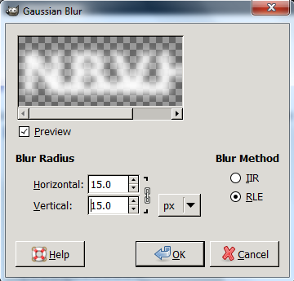
  - Now choose Colors Curves
  - Select “Alpha” as the channel
  - Move the bottom left point of the graph to the center, and move the top point of the graph to the center (see below)
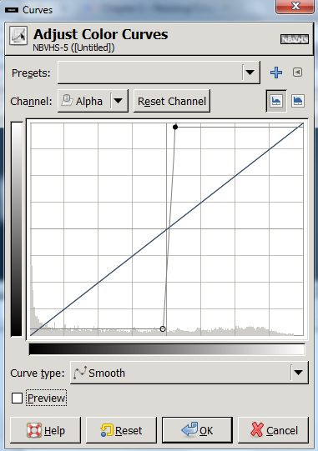
If you have preview selected, your work will look like this so far:
  - The next step is to go to Filter Alpha to Logo Neon and then enter the values as shown in the image below:
    - Effect size = 40
    - Background colour = black
    - Glow colour = choose any “neon’ish” colour that you find attractive

It might start looking something like this
Don’t be surprised if it looks a bit different.
- Adding More Glow
  - Go to the Layers Dialog. You now have a layer named “Neon Tubes” and another named “Neon Glow”.
  - Click on the “Neon Glow” layer and duplicate it.
  - On the layer that you duplicated, go to Filter Blur Gaussian Blur. Choose 35px for Blur Ratios.
You did this last step just to get some more “glow” but without messing up the original Neon Glow layer.

SAMPLE

