Digital Imaging
Assignment 3: DI_03

Instructions

In this assignment, you will create a photo montage. A photo montage is a composite photograph created by cutting and joining a number of other photographs into one composite image. Your photo montage will be a self portrait. You will be the subject of your composition. Your montage must include the following:
- A picture of yourself.
- A minimum of two artifacts that represent who you are as a high school student. You may have to scan these items.
- Your “signature” created with the text tool.
- A textured background. The texture can be one that you create using a built in effect or something that you find on the Internet or scan but it must convey a texture. For example, in the sample montage, a wrinkled piece of paper was used to convey a rough, wrinkled background as opposed to a smooth surface.

A sample montage is shown on the next page. This is only a sample. You may use any items, in any combination, to create a sense of who you are—to create that “impression” that will tell me all about you! How you process and combine the items is just as important as what those items actually are. Two items is the minimum. You may use more but take care in how you arrange them and blend them into the overall finished product.

The first two columns (on the left of the following chart) show the items that were used to create the sample, self portrait montage (shown in the column on the right):

Picture of  yourself | - 2 “artifacts” (picture of ancestors and excerpt from diary)  - Crumpled paper to use for textured background  - signature | The final product  Self portrait montage
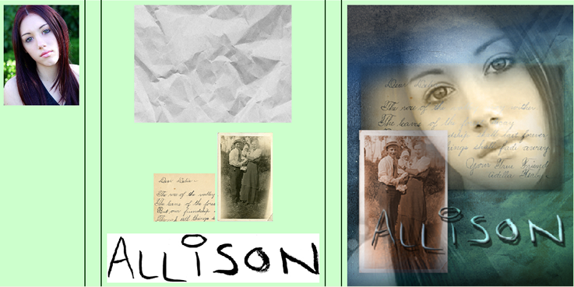

Technical Requirements:

- Your montage must include the use of:
  - Masks
  - Gradients to fade selections
  - Layers
  - Filters
- Set your canvas size to 8 inches x 10 inches and resolution to 300.
- Use multiple layers in creating your montage. Make sure each layer is named. For example, your background layer would be named “background”.
- Arrange, filter, and blend your layers to create a self-portrait that is creative and captures the essence of you—the “real you”!
- Open a Word document. Copy and paste your original images into the Word document and beside each image, describe in point form the:
  - Tools used and how you processed each image before adding it to the montage.
  - The techniques you used to combine the images—for example, how you used gradients, filters and masks.
- Make sure you review the assignment rubric before submitting your assignment.

