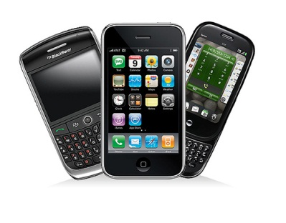
The Competitive Environment
Porter’s Five Forces (with a focus on Canadian cell phone providers)
- Threats of new competition refer to the threat of other firms (competitors) entering your market. The threat of new cell phone competitors is fairly low. There are significant investment costs to start a cell phone service company (e.g., purchase infrastructure, develop a sales network, etc.). The costs associated with these investments as well as having to develop brand recognition may keep some companies from entering the industry.
- Threats of substitute products refer to the threat of customers shifting to a similar product. The threat of substitute products is moderate. There are a few substitute products, such as Skype, Google Chat or a landline. However, they may not be great substitutes for a cell phone, because they are not as convenient to use. With this said, customers may switch to these substitutes because they are cheaper.
- Bargaining power of customers refers to the power of customers to influence the pricing of products. The bargaining power of consumers is low. Consumers have practically no ability to bargain with cell phone service providers. There are a lot of consumers and very few cell phone providers. It is true that a single consumer can leave Rogers and take his/her business to Telus, but this will not affect Rogers on a large scale. Cell phone service providers on the most part provide pricing plans that are similar (i.e. within a range of $10-15). They try to differentiate on various perks outside of pricing, such as unique phones.
- Bargaining power of suppliers refers to the power of suppliers who provide the materials that are needed to make a product or for a product to function. The bargaining power of suppliers (cell phone manufacturers) is relatively low. There are very few cell phone service providers who will purchase cell phones and there are a lot of cell phone manufacturers. The only time where this power dynamic might shift is when a cell phone manufacturer has a unique product. This was the case with Apple when it first came out with its i-Phone.
- Intensity of competitive rivalry refers to the pricing competitiveness in the industry between firms. As noted above, the competitive rivalry is modest-to-low in the cell phone service industry. The cost of cell phone plans has not varied much. If one of the major companies dropped its contract price then the other companies would follow suit. As a result, all companies would lose out because their profits would be significantly reduced. Therefore, cell phone companies try to avoid competing on price. For example, how may cell phone commercials from the big companies do you see where they advertise monthly contract prices? Typically they will compete on service area covered or other features (i.e. unlimited data).

Which of the five forces is your group assigned?

Create a list of 3-5 things that might influence how your force relates to different companies/industries. What types of companies/industries face high threats to competition? Low threat to competition?

Macchiatos in Mumbai: Starbucks Comes to India

February 9, 2012

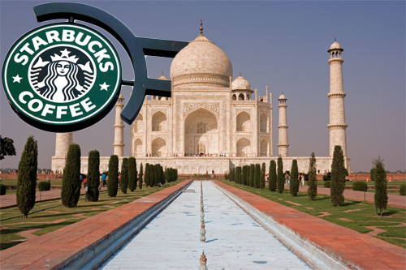

Last week, a New York Times global edition blogger talked to young people in India who frequent the country’s growing number of coffee houses. It seems that a country known for drinking chai tea throughout the day is happy about the latest development in the designer coffee scene: Starbucks is coming to India. “Almost everyone orders a cappuccino. We drink so much coffee, it doesn’t really help us stay awake anymore,” Somani, 18, told the New York Times. “I would be super-excited about a Starbucks in town – I love their Frappuccinos.”

Seems the business world is excited over Starbucks’ prospects in India, as well. After Starbucks detailed the roadmap for its entry into the Indian market last week, among the first to see an impact was Tata Global Beverages. Shares of the company, which has a joint venture with the Seattle-based coffee giant, jumped more than 10% on the Bombay Stock Exchange the next day. The increase reflected investor confidence in the prospects of Tata Starbucks, the 50-50 partnership between the two firms. “We are excited about the opportunities the alliance presents,” Tata Global vice chairman R.K. Krishnakumar said during the announcement.

Selling under a Hybrid Brand
The first India Starbucks locations are scheduled to open in August in New Delhi and Mumbai. Company officials have hinted that the grand opening could be August 15, India’s Independence Day. With an initial investment of around $80 million, the Tata-Starbucks partnership is expected to open 50 stores in the country in 2012. The locations will be branded “Starbucks Coffee — A Tata Alliance,” an unusual move, as the Seattle firm does not typically sell its products under a hybrid brand. The stores will be offering a range of teas in an effort to cater to local tastes. The Tata Group is an Indian multinational conglomerate company that operates in a variety of business sectors, from beverages to cars.
Tata observers note that the partnership is a continuation of a trend. When Pepsi came to India, it did so as part of a joint venture with Tata Group subsidiary Voltas. The product name in that case was also a hybrid — Lehar Pepsi — due to restrictions on sale of foreign brands in India. Once the laws were changed, and Coca-Cola entered the country on its own, Pepsi parted ways with Voltas.
Due to the current legal framework, Starbucks could have come to India without a partner; instead, it chose to enter into the venture with Tata. In addition, observers note, Tata had no experience in consumer products at the

time of the Lehar Pepsi launch, while Voltas was a marketing company that had handled successes such as dairy products brand Amul and soft drink concentrate manufacturer Pioma Industries (which sells under the popular brand name Rasna).
This time, the Tatas bring much more to the table, observers say. First, they have developed considerable retail experience, through chains such as Westside (clothing and accessories), Landmark (books), Croma (consumer electronics) and Titan (watches and jewelry). In fact, according to economic daily Business Standard, Noel Tata, who oversees many of the retail brands, is likely to be asked to oversee the Starbucks venture. “We are putting a high-caliber leadership team in place,” John Culver, president of Starbucks China and Asia Pacific, told the newspaper.
The Coffee ‘Experience’
But the big benefit that the Tatas bring is the large number of outlets available in different sectors and under different names, some of which could be used to accommodate Starbucks cafes. This provides a cheap entry point in a country where real estate is often one of the biggest costs for any retail venture. “We are keen to sell our products in multiple channels, such as hotels, restaurants, colleges and universities,” said Culver. “As part of this, we want to look at where we can place our stores in Tata hotel properties.”
Although coffee was practically virgin territory in India five years ago, Starbucks now faces considerable competition. Indian chain Cafe Coffee Day (CCD), for example, has more than 1,000 outlets. A dozen more chains, including Barista and Costa Coffee, have also established themselves. But competition may be helping the market grow. According to Technopak, a New Delhi-based research firm, the more than $200 million sector has been expanding at a compound annual rate of 25%. Information technology entrepreneur Subroto Bagchi gives one reason why. “CCD has raised coffee from a brew to an experience,” he told IndiaKnowledge@Wharton. Said Culver of Starbucks: “We look forward to bringing the ‘Starbucks Experience’ to customers in India.”

