Value | 30 marks (5 marks for each business environment)
Due Date

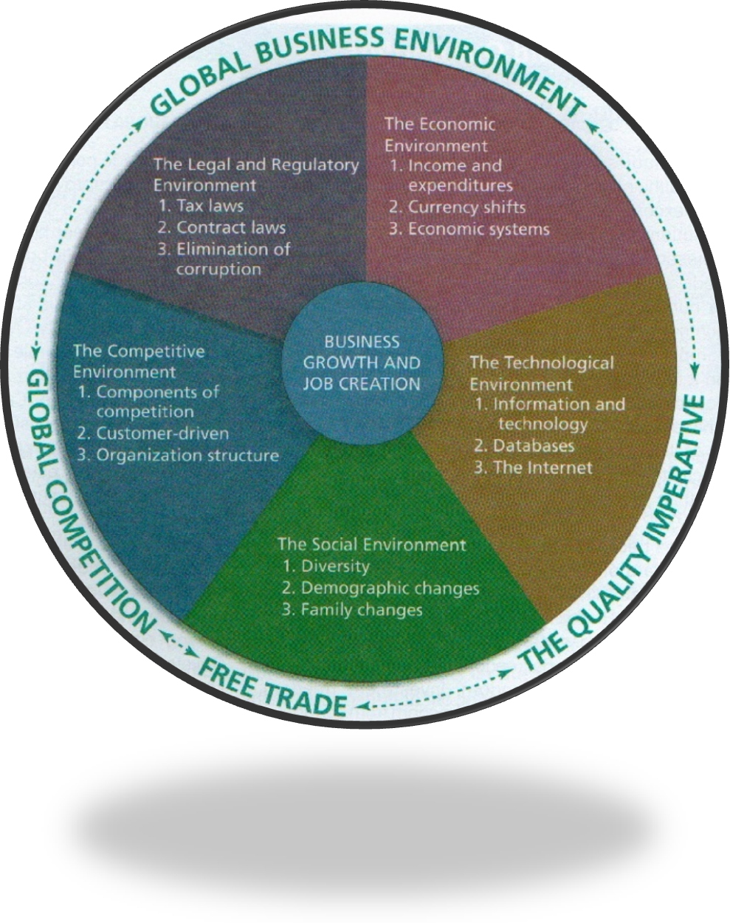
Instructions
The Journal is to be in a duo-tang or notebook.

You are to find a business article that relates to each business environment.

The six business environments include:

- The Legal and Regulatory Environment
- The Economic Environment
- The Technological Environment
- The Social Environment
- The Competitive Environment
- The Global Business Environment

The Duotang Must Contain
- A copy of the business article
- Identify the business environment the news story relates to and one paragraph with a minimum of five sentences telling me how the news story impacts the business environment or how it is connected

How Each Business Article Will be Assessed
Item | Value
Provides a business environment article | 2
Provides no example of why article relates to the business environment | 0
Alludes to an example, but doesn’t integrate it | 1
Provides an example of why article relates to the business environment | 2
Provides clear examples of why article relates to the business environment | 3

Resource Websites
Website | Address
Atlantic Business Magazine | http://www.atlanticbusinessmagazine.ca/
BNN – Business News Network | http://www.bnn.ca/
Canada East | http://www.canadaeast.com/
Canadian Business | http://www.canadianbusiness.com/
CBC Business News | http://www.cbc.ca/news/business/
Financial Post | http://www.financialpost.com/index.html
Progress Magazine | http://www.progressmedia.ca/
The Globe and Mail | http://www.theglobeandmail.com/report-on-business/

