OBJECTIVES
Layers Dialog Show Grid
Layer Visibility Save As
Canvas Size Brushes
Script-Fu Animation
Drawing Lines
Snap to Grid
GIMP
Assignment 18
Animated Sphere

Preparation
- Create a new folder named “Assignment 18” within the “GIMP Assignments” folder.
- Open GIMP
- Create a new image that measures 500 px by 500 px, with a transparent background.
Assignment Tasks
Modify Grid
- Go to the View menu and activate the Show Grid and the Snap to Grid options.
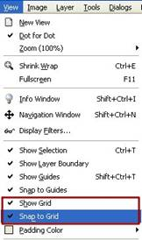

- Go to the Image menu and choose Configure Grid.
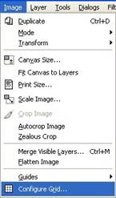
- Now that you have the Configure Grid dialog box open, adjust the settings to that they match those of the image below.
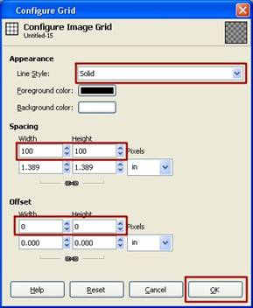
- If you chose the settings from step c), your GIMP image should look like this:
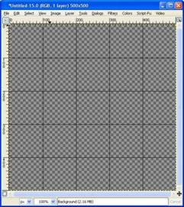
Draw Straight Lines
- Choose a Brush (use any size, use a hard or soft brush)
- Choose a colour shown in the image from step c)
- Place your cursor in one of the coordinate locations shown, in red, in the image below. Click once with the brush. While holding down the SHIFT key, click at the coordinate location opposite from the first click.
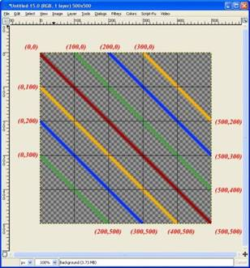 | From the bottom left to the top right:  Green line (0,300) to (200,500)  Blue line (0,200) to (300,500)  Yellow line (0,100) to (400, 500)  Red line (0,0) to (500,500)  Green line (100,0) to (500,400)  Blue line (200,0) to (500,300)  Yellow line (300,0) to (500, 200)  Your coordinates can be slightly off, but not by too much. It will make a difference.

- Notice the colour arrangement. For your colours to line up correctly on the sphere, you must have them in this order.
Canvas Image
- Go to Image menu and choose Canvas Size.
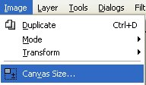
- Change the settings to match these:
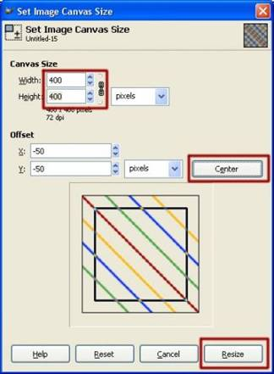
- Go over to the Layer Dialog window. Right-click on the layer and choose Layer to Image Size.
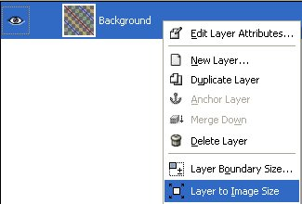
- Your GIMP image screen should look like this:
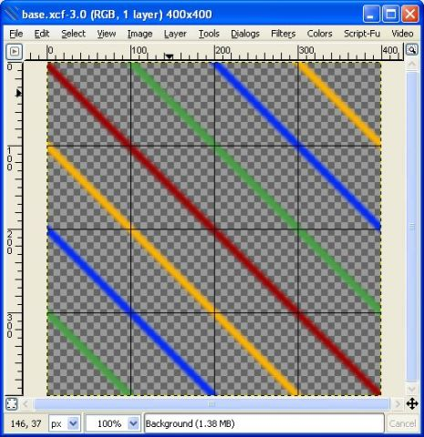
Create the Animation
- Go to Filters Animation Spinning Globe.
- Change the following settings:
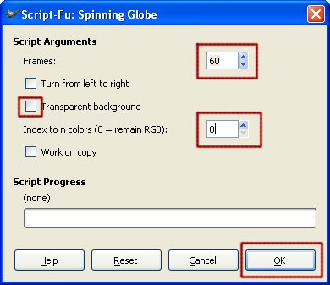
- Go to Filters Animation Playback.
Save your work
- Save as a XCF file
  - Go to File Save As
  - Save it to your Assignment 18 folder
  - Save it as spinningglobe.xcf
- Save as a GIF file
  - Go to File Export
  - Choose Save as Animation
  - Save it to your Assignment 18 folder
  - Save it as spinningglobe.gif
- Compress the two files (spinningglobe.xcf and spinningglobe.gif) into a new ZIP file called spinningglobe.zip
- Submit only one file, spinningglobe.zip, to the GIMP Assignment #18 folder
SEE THE NEXT PAGE
FOR THE SAMPLE IMAGE

SAMPLE OF WHAT THE FINAL IMAGE WILL LOOK LIKE
Yours will be animated – if it is animating on this assignment,
you may want to get some more sleep!

