Name: Date:

The UN Global Compact was enacted in July 2000, and now over 5300 business have voluntarily signed on to make a commitment to make the Global Compact’s ten principles part of their business strategies.

Please read the ten principles and then think of one company (it could be small or big, local or international, it doesn’t matter), and think of one way (concrete example) that that company already is or could start incorporating the principles into their business practice.

For example: Principle 5 – the effective abolition of child labour – Nike: boycott all purchasing of materials from factories employing child labourers.

Name of Company:

Principle 1:

Principle 2:

Principle 3:

Principle 4:

Principle 5:

Principle 6:

Principle 7:

Principle 8:

Principle 9:

Principle 10:

The Ten Principles of the UN Global Compact

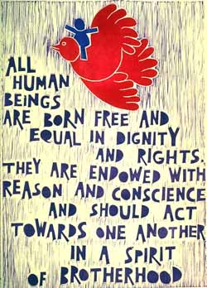
The UN Global Compact's ten principles in the areas of human rights, labour, the environment and anti-corruption enjoy universal consensus and are derived from:
- The Universal Declaration of Human Rights
- The International Labour Organization's Declaration on Fundamental Principles and Rights at Work
- The Rio Declaration on Environment and Development
- The United Nations Convention Against Corruption
The UN Global Compact asks companies to embrace, support and enact, within their sphere of influence, a set of core values in the areas of human rights, labour standards, the environment and anti-corruption:
Human Rights
- Principle 1: Businesses should support and respect the protection of internationally proclaimed human rights; and
- Principle 2: make sure that they are not complicit in human rights abuses.
Labour
- Principle 3: Businesses should uphold the freedom of association and the effective recognition of the right to collective bargaining;
- Principle 4: the elimination of all forms of forced and compulsory labour;
- Principle 5: the effective abolition of child labour; and
- Principle 6: the elimination of discrimination in respect of employment and occupation.
Environment
- Principle 7: Businesses should support a precautionary approach to environmental challenges;
- Principle 8: undertake initiatives to promote greater environmental responsibility; and
- Principle 9: encourage the development and diffusion of environmentally friendly technologies.
Anti-Corruption
- Principle 10: Businesses should work against corruption in all its forms, including extortion and bribery.

